Large-Scale Associations of BMI and Clinical Obesity With Cardiac Field Artifact in Scalp EEG
Nir Cafri^{1,3}, Felix Benninger^{2,3}, Pablo Blinder^{1,2}
¹Department of Neurobiology, School of Neurobiology, Biochemistry and Biophysics, George S. Wise Faculty of Life Sciences, Tel Aviv University, Tel Aviv, Israel
²Sagol School of Neuroscience, Tel Aviv University, Tel Aviv, Israel
³Department of Neurology, Rabin Medical Center, Beilinson Hospital and Tel-Aviv University, Petah Tikva, Israel
Correspondence: nircafri@mail.tau.ac.il

Abstract
Heartbeat-evoked potentials (HEPs) are widely used to study cortical cardiac interoception, but they are inherently vulnerable to contamination from the heart’s electrical field, which is time-locked to the same R-peak. We quantified this cardiac field artifact (CFA) in 7,995 clinical polysomnography recordings, comprising 98,203 channel-recordings. For each EEG channel, the R-peak-locked average was regressed against the simultaneous ECG average from −300 to 400 ms, both across the full epoch and after excluding the ±50-ms QRS interval. As an independent validation, ECG-informed independent component analysis (ICA) was used to estimate the variance removed with the ECG-correlated component. Even outside the QRS interval, ECG explained a substantial fraction of EEG variance (mean R² = 0.32, SD = 0.29; full epoch R² = 0.35), while ICA removal reduced HEP-evoked variance by a median of 28%. CFA also varied systematically across electrodes and participants. It was higher in male than female patients (0.37 vs. 0.32) and in patients with versus without a linked diagnosis (0.35 vs. 0.27), with obesity showing the largest diagnosis-associated difference. CFA also rose more steeply with BMI in female than male patients (r = 0.14 vs. 0.09), though this sex difference in slope was not itself significant (interaction p = 0.67). In 7,079 matched patients, mean CFA R² rose from 0.30 using 5-minute segments to 0.42 using 60-minute segments, suggesting that short recordings underestimate detectable cardiac contamination. These findings show that CFA is not a fixed nuisance signal, but a channel- and participant-dependent source of variance. HEP studies should therefore quantify cardiac contamination at the channel level and account for factors such as BMI, obesity, and sex when cleaning EEG data and comparing groups.
Keywords: cardiac field artifact; heartbeat-evoked potential; interoception; independent component analysis; EEG-ECG volume conduction; population neuroscience; polysomnography

1. Introduction
Every heartbeat volume-conducts an electrical field into scalp EEG electrodes with a fixed phase relationship to the R-peak — the same event used to time-lock heartbeat-evoked potential (HEP) epochs. This cardiac field artifact (CFA) survives ordinary trial averaging as well as genuine cortical interoceptive signal does,¹ and the standard mitigation is to exclude a short window around the QRS complex (commonly ±30-50 ms) from analysis.³⁻⁵ What that mitigation has not been given at population scale is a number: how much of the HEP that survives QRS exclusion is still explainable by the cardiac field, and whether that fraction depends on who the patient is (age, sex, diagnosis) or is a fixed instrumental constant. Existing CFA characterisations are small (typically tens of participants) and single-cohort, too underpowered to answer either question.
This distinction matters because an R-peak-locked scalp waveform is a mixture, not a direct measurement of one source. Neural responses to baroreceptor and somatosensory input may coexist with passive cardiac volume conduction, and both survive heartbeat-locked averaging.^{2,3,8} Consequently, a group difference in HEP amplitude can reflect cortical processing, cardiac electrophysiology, tissue conduction, electrode geometry, or a combination of these factors. Recent reviews document substantial heterogeneity in CFA handling and warn that inconsistent preprocessing limits reproducibility and clinical interpretation.^{4,5,9} Quantifying the residual ECG-related variance is therefore a prerequisite for interpreting HEPs as neural biomarkers rather than merely a technical refinement.
CFA may also vary systematically between people. Body composition alters the geometry and conductive path between heart and scalp. In surface ECG, subcutaneous fat attenuates cardiac voltage, and correcting voltage for measured body fat changes its relationship with cardiac structure and ambulatory blood pressure.¹⁰ Sex, age, and disease burden covary with body composition, cardiac morphology, rhythm, and medication exposure. Clinical obesity and BMI are therefore of particular interest, but neither directly measures body-fat distribution; the present data cannot isolate fat mass from correlated cardiometabolic conditions. If these characteristics predict CFA, they are potential confounders in between-group HEP analyses and should be measured or modelled rather than assumed to disappear after a fixed QRS exclusion.
We answer both questions using this project's clinical polysomnography corpus, applying two independent estimators to the same HEP epoch window used throughout this project's other analyses. A model-free estimator regresses each channel's own R-peak-locked HEP evoked average directly on that patient's R-peak-locked ECG evoked average, requiring no assumption that ICA correctly separates cardiac from neural sources. A model-based estimator runs an ECG-informed ICA artifact-removal pipeline and measures both the flagged component's share of HEP-evoked variance and the actual variance drop from removing it. Applied across 7,995 patients — to our knowledge the largest cohort in which CFA's HEP variance contribution has been quantified — this lets us test population stability with statistical power no prior single-site CFA study has had. We further test whether recording duration changes the apparent contamination, because a short segment may contain too few heartbeats to stabilize an evoked average. Our prespecified expectations were that ECG-related variance would remain outside QRS, would vary by channel and patient characteristics, and would increase as longer windows revealed a more stable shared signal.

2. Methods

2.1 Cohort and recordings
Demographics were available for 7,738 patients (median age 61 years, range 7-103; Male n=3,965, Female n=3,767), drawn from The Human Sleep Project.¹⁴ BMI was derived from median patient height and weight recorded in the longitudinal vitals flowsheet and hospital admission table; values outside 10-80 kg/m² were excluded as implausible. EDF recordings were drawn from this project's multi-source clinical polysomnography corpus (predominantly this cohort's EEG/EHR-linked group, with smaller contributions from other project source cohorts). For each recording, one reproducible, quality-controlled 10-minute window was selected (seeded random search; EEG/ECG signal-quality and physiological-plausibility thresholds), matching the window-selection procedure used throughout this project's HEP pipeline so both estimators score the same kind of data the project's HEP science itself uses. EEG/ECG channels were identified by a whitelist match against standard 10-20/10-10 electrode names (to exclude iEEG depth electrodes and auxiliary/DC channels present in this heterogeneous corpus) and an ECG/EKG channel-name pattern match. Signals were read and band-pass filtered 1-100 Hz with MNE-Python.⁷ HEP epochs spanned -300 to 400 ms around each detected R-peak, matching this project's own HEP cluster-statistics pipeline; the ±50 ms QRS-exclusion window used there, following standard HEP methodology,⁵ was reused unchanged here.

2.2 EEG cleaning pipeline
Each EDF's quality-controlled window was cleaned before CFA estimation using the same standard EEG cleaning pipeline used throughout the project's HEP analyses. Channels were renamed/typed and resampled to 256 Hz; a 0.5 Hz-Nyquist band-pass and a harmonic notch filter at the recording's detected line frequency were applied. Bad EEG channels were flagged and re-referenced or repaired via the PREP pipeline where it converged, then interpolated; remaining artifact was removed with AutoReject. EEG channels were then standardized per channel before downstream analysis. This cleaning is independent of the two CFA estimators themselves (§2.3-2.4): the model-based estimator's own ICA decomposition (§2.4) runs on top of this already-cleaned signal.

2.3 Model-free CFA estimator: HEP-vs-ECG regression
For each patient and EEG channel, the R-peak-locked evoked average (mean across epochs) was computed for that channel and, separately, for the patient's own ECG lead over the identical epoch window. The squared zero-lag Pearson correlation (R²) between the two evoked waveforms was taken as the fraction of that channel's HEP-evoked variance explainable by the cardiac field, reported both over the full epoch and restricted to samples outside the ±50 ms QRS window. This estimator makes no assumption about ICA's ability to isolate a cardiac source; it asks directly whether the averaged scalp deflection is, in effect, a scaled copy of the averaged heartbeat.

2.4 Model-based CFA estimator: ECG-informed ICA
Independently, ICA⁶ (Picard, extended-Infomax fallback; up to 15 components) was fit on the same quality-controlled window, and the component most correlated with the ECG channel was flagged as the cardiac-artifact component (MNE's⁷ ECG-correlation scoring, matching this project's own artifact-removal pipeline). Rather than reporting the component's share of raw continuous-signal variance, each component's mixing-weighted contribution was evaluated on its own R-peak-locked evoked average, i.e. how much of the heartbeat-evoked (not generic continuous) signal the component explains. Separately, the actual cleaning effect was measured directly: each channel's HEP-evoked variance was compared before and after excluding the flagged component via ICA back-projection, giving the realised percentage variance drop rather than only the component's notional share.

2.5 Statistics
Age was tested two ways against patient-mean CFA R² (outside QRS): as a continuous variable via Pearson correlation, and by tertile via one-way ANOVA. Sex and linked-diagnosis differences, being two-group comparisons, were tested with the Mann-Whitney U test given the right-skewed R² distribution. Diagnosis-category comparisons (§3.3) used the Kruskal-Wallis omnibus test with pairwise Mann-Whitney tests, Benjamini-Hochberg FDR corrected across all pairwise comparisons. BMI was tested continuously with Pearson correlation. To include all sites without duplicating patients, the BMI analysis selected each patient's longest available CFA window, retaining exactly one patient-level observation. BMI correlations were then estimated separately by sex, and an ordinary least-squares BMI-by-sex interaction tested whether the slopes differed. A supplementary ordinary least-squares model compared the sex coefficient before and after adjustment for BMI in the same matched subset.

2.6 Channel canonicalisation and minimum coverage
Raw channel labels were canonicalised to their scalp-side 10-20 site; labels representing only a reference electrode were excluded. Figure 2 reports every canonical site with at least 500 patients. Figures requiring a cross-condition or cross-estimator comparison at a shared set of electrodes (§3.3-3.4, S2-S4) instead keep only canonical sites present in at least 50% of that figure's patients; in practice this restricts those figures to six sites (F3, F4, C3, C4, O1, O2, each covering 96-100% of patients) that dominate this corpus's montage.

2.7 EEG-ECG cross-correlation and mutual information
Supplementary Figures S3-S4 measure the EEG-ECG relationship further ways, on an independent 150-patient subsample. Lag-resolved cross-correlation: Pearson correlation between each channel's evoked waveform and the concurrent ECG evoked average at lags spanning ±100 ms in 5 ms steps (rather than only the zero-lag value used in §2.3), reporting the peak absolute correlation and its lag (sign-flipped per channel first, since reference polarity is arbitrary). Mutual information: the Kraskov k-nearest-neighbour estimator, capturing nonlinear as well as linear EEG-ECG dependence. Both run on three conditions: pre-ICA, post-ICA, and a non-heartbeat-locked control that re-epochs the same quality-controlled window around random pseudo-event times instead of true R-peaks. A fourth condition, the patient's own ECG evoked average, is added for the power-spectral-density comparison only (Figure S4): Welch PSD (dB) of each condition, restricted to the six well-covered electrodes (§2.6) plus ECG.

3. Results

3.1 Cohort
Demographics were available for 7,738 patients (median age 61 years, range 7-103; Male n=3,965, Female n=3,767). This is a clinically referred polysomnography population with a high diagnostic burden, not a healthy community sample — the most prevalent categories were Obstructive Sleep Apnea (n=5,524); Hypertension (n=3,882); Obesity (n=3,016) (diagnosis categories are not mutually exclusive). Full cohort composition is given in Supplementary Figure S1.

3.2 Model-free and ICA-based CFA variance explained
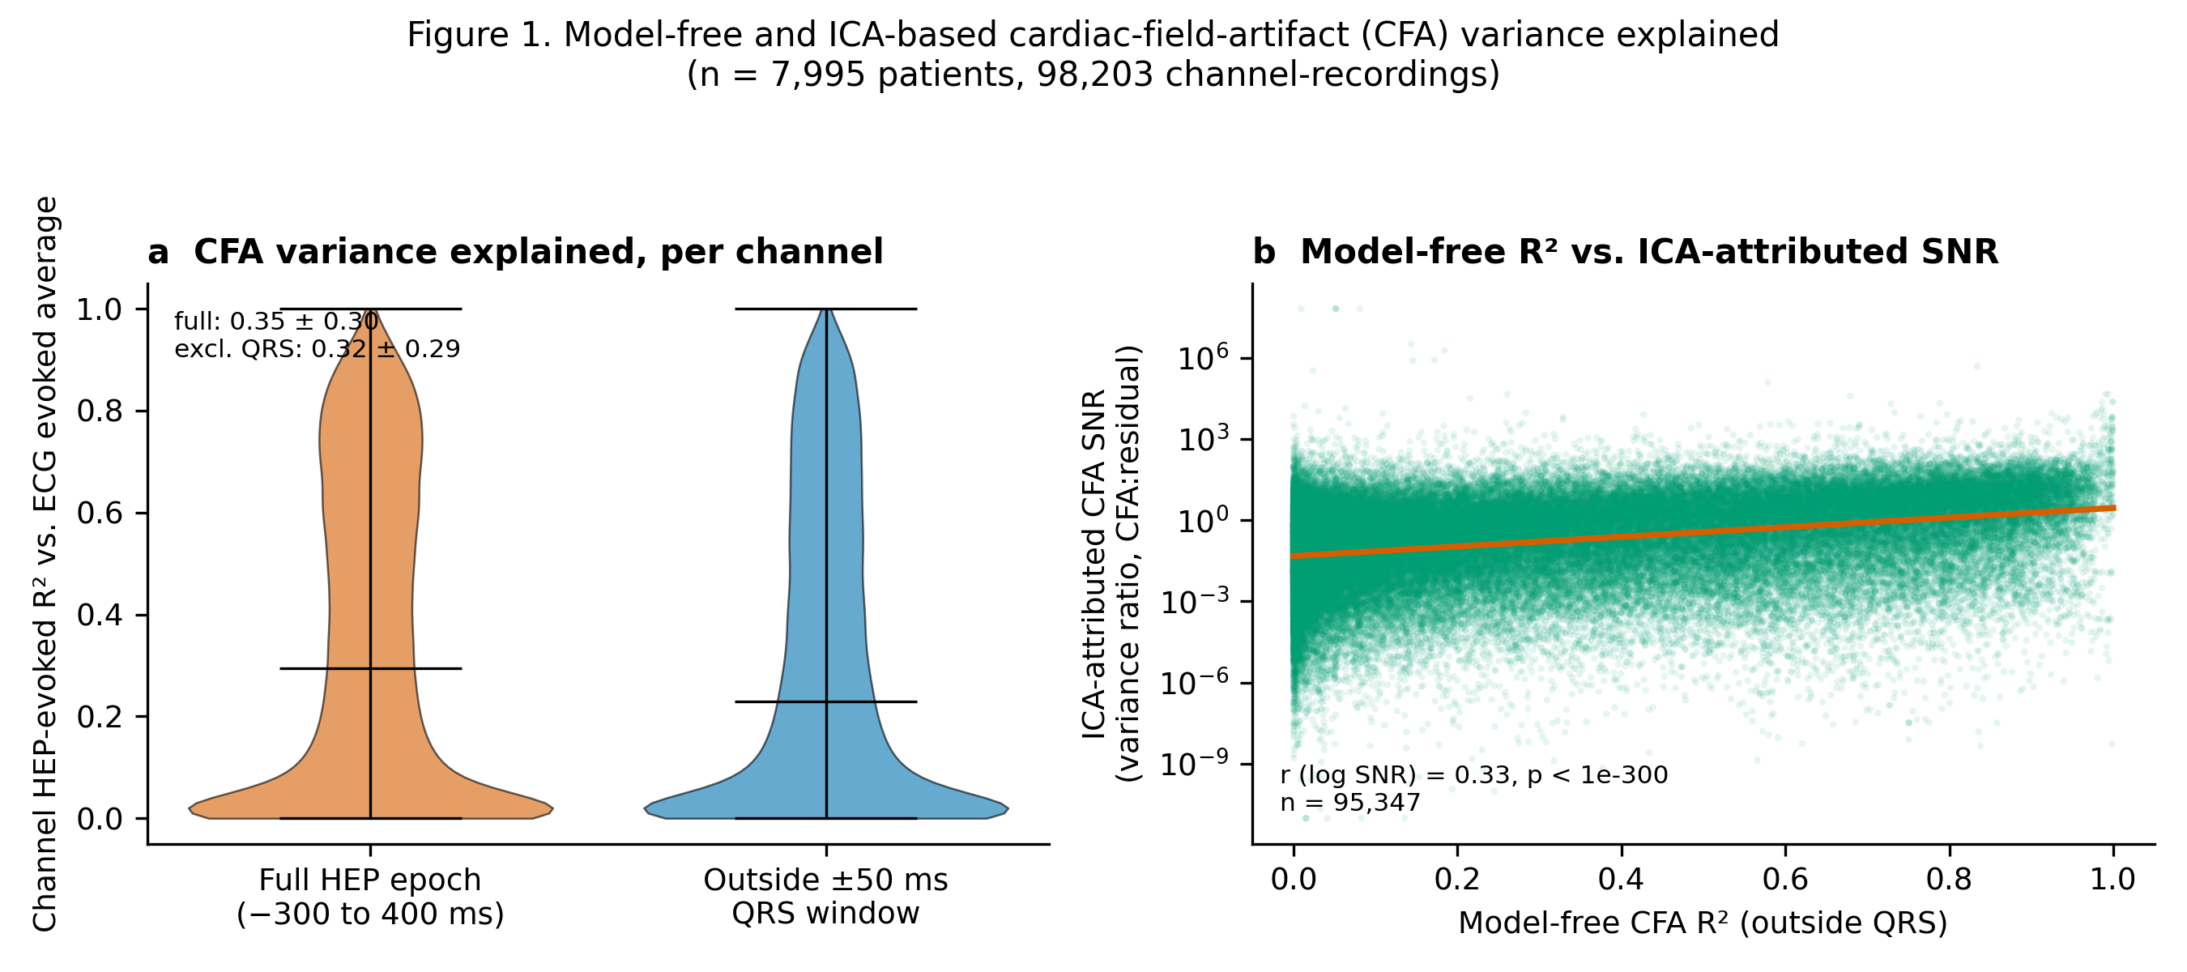
Figure 1. CFA variance explained by two independent estimators across 7,995 patients (98,203 channel-recordings). (a) Model-free: distribution of per-channel R² between the HEP evoked average and the ECG evoked average, over the full epoch (mean 0.35) versus restricted to outside the ±50 ms QRS-exclusion window already used for this project's HEP cluster statistics (mean 0.32). (b) Model-based (interim ICA snapshot, 7,933 patients): the ECG-flagged ICA component's variance ratio plotted against that same channel-recording's model-free CFA R² from panel (a) (all channels, SNR axis log scale, trend line = least-squares fit of log SNR on R²; r = 0.33, p < 1e-300, n = 95,347). No channel-level variance threshold was applied.
Even outside the conventional QRS-exclusion window, the ECG evoked average still explained a substantial share of channel HEP-evoked variance (mean R² = 0.32, median 0.23) — somewhat less than the full-epoch estimate (mean R² = 0.35), but the drop is modest, not the order-of-magnitude reduction QRS exclusion is implicitly assumed to achieve. The two independent estimators agree in direction: a substantial share of HEP-evoked variance is attributable to the cardiac field by both a model-free regression against the patient's own ECG and a model-based ICA decomposition with actual component removal.
Across all channels, without discarding small component loadings, the ECG-flagged component carried a median 21% of HEP-evoked variance. The realised cleaning effect was larger: excluding that component reduced channel HEP-evoked variance by a median 28%. The dispersion in Figure 1b is expected because one globally selected ICA source does not load equally on every electrode and because ICA source variance and the change after back-projection are related but not identical quantities. Accordingly, the per-channel ECG regression is the primary estimate, and ICA removal provides convergent evidence rather than a threshold-based definition of CFA.
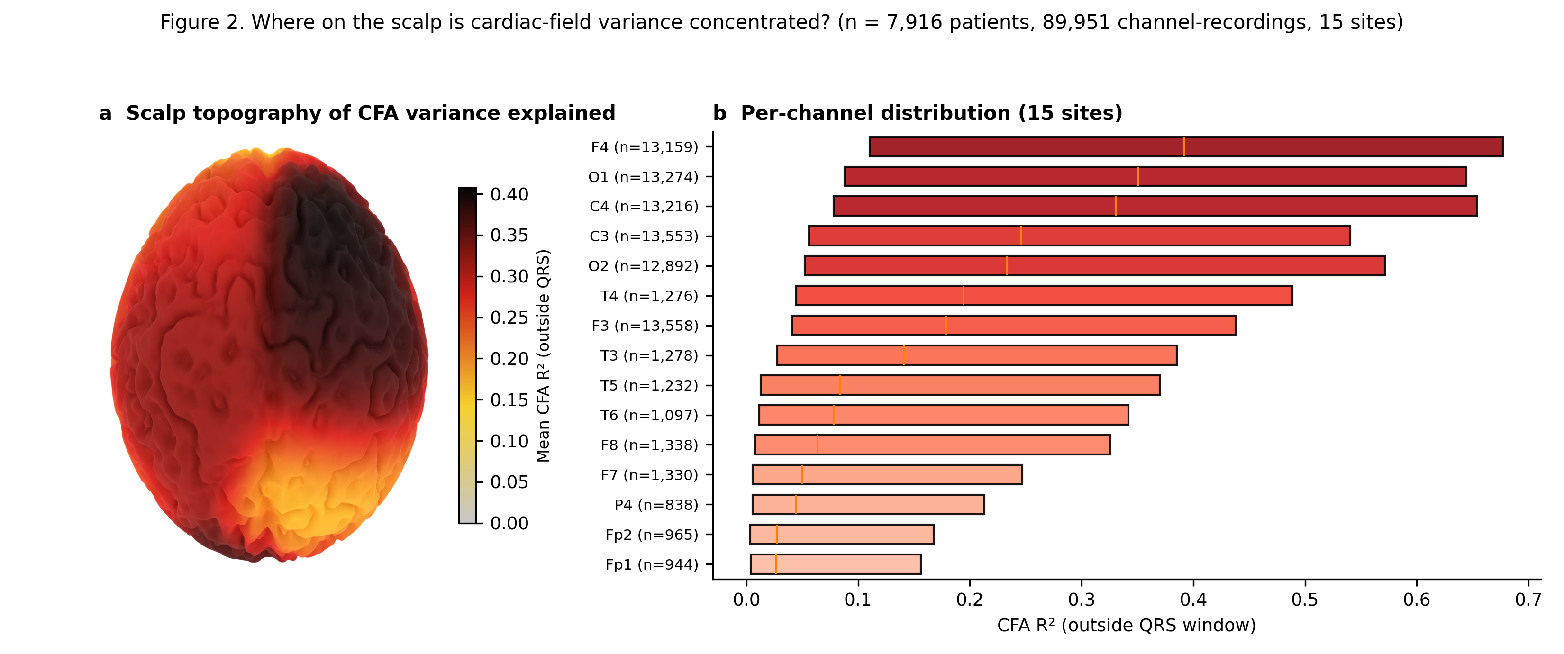
Figure 2. Scalp distribution of CFA variance explained (15 canonical 10-20 sites with at least 500 patients, 89,951 channel-recordings; bipolar/mastoid-referenced channel labels were canonicalised to their scalp-side site; Cz, Fz, Oz, P3, Pz were dropped for falling below the 500-patient floor). (a) Topomap of mean CFA R² (outside QRS) per site. (b) Full per-channel R² distribution, sorted by median (orange line); box = IQR; n per site shown — coverage is uneven, from the six montage-standard sites (F3/F4/C3/C4/O1/O2, n > 12,000 each) down to sites near the 500-patient floor, so the low-n sites' point estimates are noisier.
CFA is not uniform across the scalp: it is highest at F4 (mean R² = 0.41) and lowest at Fp1 (mean R² = 0.12), roughly a 3.3-fold range. A fixed, site-independent CFA correction is therefore a worse approximation at some electrodes than others; the per-channel regression correction this paper uses (§2.3) automatically adapts to it.

3.3 CFA variance explained by diagnosis category
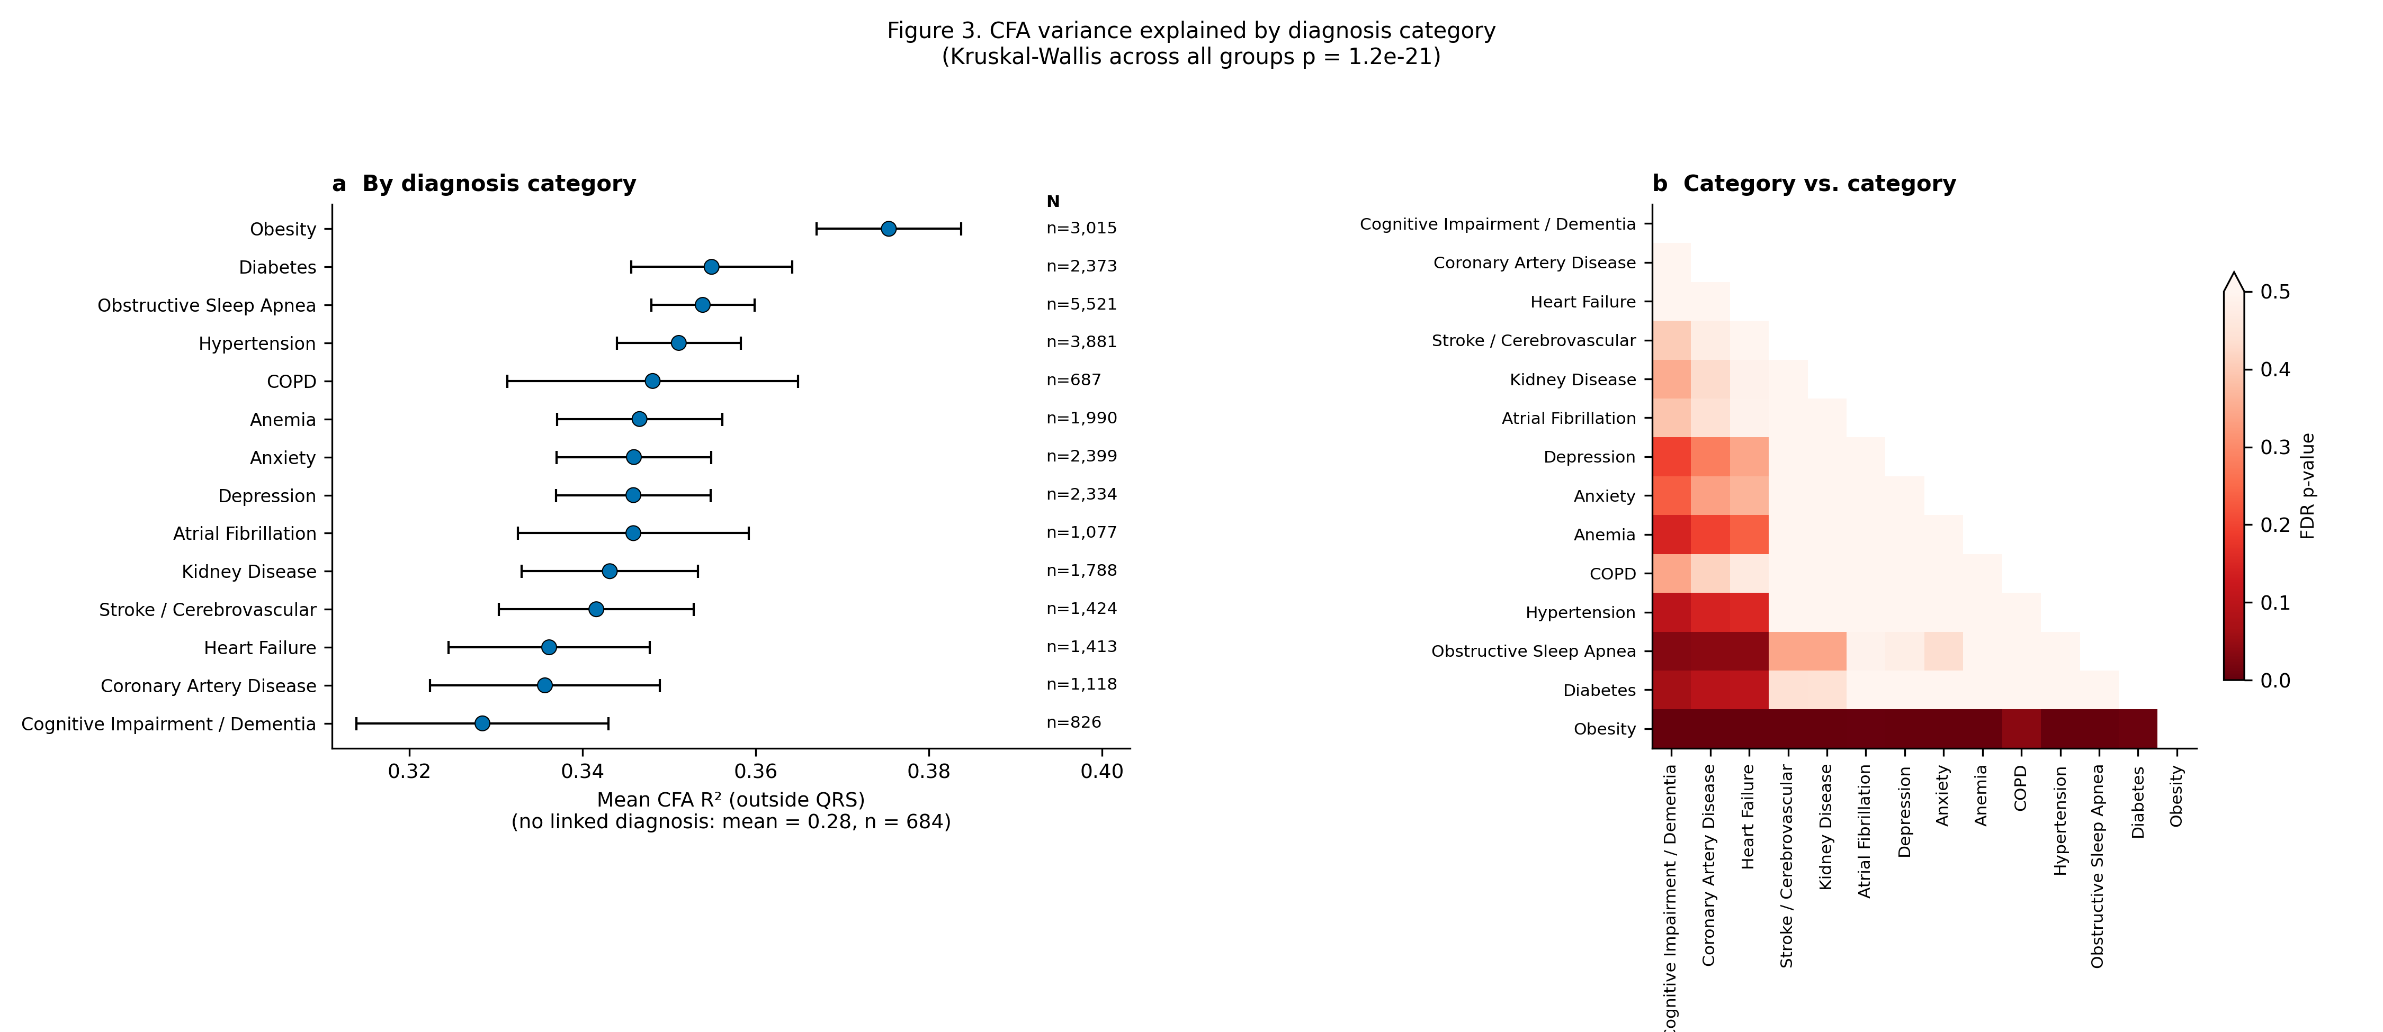
Figure 3. (a) Forest plot: mean patient-mean CFA R² (outside QRS) per clinical diagnosis category, sorted by value; point = mean, error bar = 95% CI (Welch, unequal-variance). Patients with no linked diagnosis at all have mean CFA R² = 0.28 (n = 684; patients may carry more than one diagnosis category). Categories are drawn from the same fifteen used throughout this project's diagnosis-based dashboards, sorted by mean; categories with fewer than 10 patients are omitted, as is Heart Transplant (n = 133; its CI crossed the no-diagnosis mean and its removal tightens the axis for the remaining 14 categories, all of which sit above the no-diagnosis mean). Kruskal-Wallis across all groups: p = 1.2e-21. (b) The same categories tested against each other, not only against the no-diagnosis reference: pairwise Mann-Whitney FDR p-values (BH-corrected across all 91 tests; color scale, white = q ≥ 0.5, red = q = 0; 16 pairs significant at q < 0.05), categories ordered as in (a).
Every one of the 14 categories sits above the no-diagnosis reference line, and 14 of 14 individually clear p < 0.05 (Mann-Whitney vs. the reference group); all 14 remain significant after FDR correction. So the diagnosed population's higher CFA R² recurs broadly across the diagnostic spectrum, not driven by one or two outlier conditions. The largest gap is in patients with Obesity (+0.10 R² units, n = 3,015); the smallest is Cognitive Impairment / Dementia (+0.05, n = 826). Categories also differ from each other, not only from the no-diagnosis reference (Figure 3b): of 91 pairwise comparisons, 16 remain significant after FDR correction, driven mostly by Obesity, whose gap is both the largest in panel (a) and significantly larger than every low-gap category.

3.4 CFA variance explained varies modestly with sex, diagnosis, age, and BMI
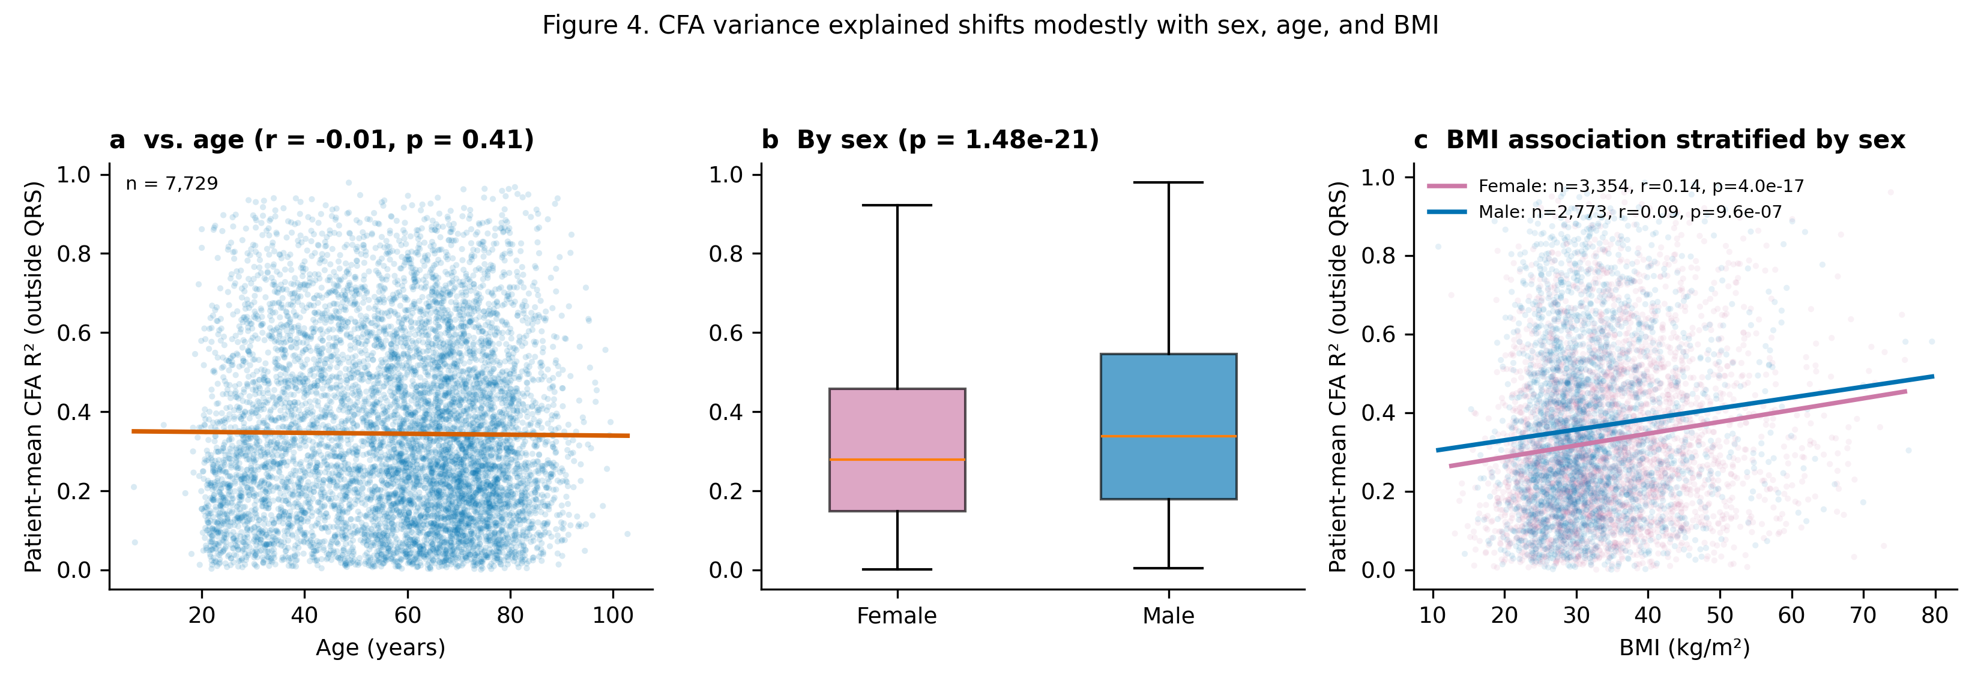
Figure 4. Patient-mean CFA R² (outside QRS) vs. (a) age, continuous (n = 7,729; Pearson r = -0.01, p = 0.41; line = least-squares fit), (b) sex (Mann-Whitney p = 1.48e-21), and (c) BMI, continuous (n = 6,127; Pearson r = 0.11, p = 4.3e-17; one observation per patient, longest available window; 5 min: n=48, 10 min: n=22, 20 min: n=72, 30 min: n=5,985; line = least-squares fit). Panel b: box shows quartiles; outliers omitted for clarity. Panel c shows sex-specific fits: female n = 3,354, r = 0.14, p = 4.0e-17; male n = 2,773, r = 0.09, p = 9.6e-07; BMI-by-sex interaction p = 0.67.
Patient-mean CFA R² was higher in male than female patients (0.37 vs. 0.32, p = 1.5e-21), higher with a linked clinical diagnosis (0.35 vs. 0.27, p = 1.6e-15), and slightly lower in the oldest age tertile than the younger two (0.33 vs. 0.35/0.35, p = 1.0e-04) — real but modest effects (absolute gaps 0.02-0.09 R² units) only this sample size has the power to resolve. Age as a continuous variable shows essentially no linear relationship to CFA R² (Figure 4a; Pearson r = -0.01, p = 0.41): the tertile means are non-monotonic, flat across the younger two tertiles before dropping only in the oldest, consistent with a threshold effect rather than a graded trend. BMI showed a positive association with CFA R² (Figure 4c; n = 6,127, Pearson r = 0.11, p = 4.3e-17). Mean BMI was 33.5 kg/m² overall, 34.8 kg/m² in female patients, and 31.8 kg/m² in male patients. This directly supports a BMI-related contribution in addition to the obesity-diagnosis comparison. The association was positive in both female patients (r = 0.14, p = 4.0e-17) and male patients (r = 0.09, p = 9.6e-07). The BMI-by-sex interaction was not significant (p = 0.67), providing no evidence that the BMI slope differs by sex.

4. Discussion
Two independent estimators — one a direct regression against the patient's own ECG, the other a full ICA decomposition with actual component removal — converge on the same conclusion: cardiac field artifact accounts for a substantial share of scalp HEP-evoked variance even after the field's standard QRS-exclusion mitigation. That share is not a fixed instrumental constant: it is reliably higher in male than female patients and in patients carrying a linked clinical diagnosis, and modestly lower in the oldest age tertile. Because CFA's magnitude tracks exactly the variables many HEP group comparisons are organised around, studies reporting a sex or diagnosis difference in raw HEP amplitude without a per-channel CFA correction cannot rule out that some of that difference is cardiac-field contamination rather than cortical response. The effect sizes are modest in absolute R² terms, so this is not grounds to discount larger sleep-stage and age HEP effects reported elsewhere — but it is grounds for per-channel CFA correction.
The concentration of noise around the QRS complex is visually and quantitatively prominent, but QRS exclusion alone is insufficient. Removing ±50 ms reduced mean explained variance only from 0.35 to 0.32; a large ECG-correlated component therefore extends into the nominal analysis interval. The positive relationship between the model-free R² and ICA-attributed CFA-to-residual variance ratio further indicates that the two methods are detecting a shared contamination process. This is the central signal-to-noise result: channels that look more ECG-like by direct waveform correlation also contain more variance assigned to the ECG-correlated ICA source. Neither estimator proves that every residual heartbeat-locked deflection is artifactual, but their convergence shows that uncorrected HEP variance cannot be assumed to be cortical.
The clinical-obesity result gives BMI and obesity status particular methodological relevance. Clinically obese patients had the largest diagnosis-associated difference (+0.10 R² units relative to the no-diagnosis reference), consistent with BMI or obesity-associated characteristics contributing to the conductive geometry that shapes the cardiac field. The independent continuous-BMI analysis supports this interpretation (6,127 patients; r = 0.11). The BMI–CFA association was numerically stronger in women than in men (r = 0.14 vs. 0.09), suggesting that women may be more sensitive to CFA variation with increasing BMI. However, the BMI-by-sex interaction was not significant (p = 0.67), so this apparent difference should not be interpreted as a confirmed sex-specific effect and requires replication. BMI is a clinical anthropometric measure rather than a direct measure of body fat. No direct fat-mass, thoracic-geometry, or electrode-impedance measure was available, and diagnosis categories overlap. We therefore interpret these findings as evidence that BMI and clinical obesity are plausible confounders, not as proof of a causal body-fat effect. Future HEP studies should record BMI and preferably direct body-composition measures and include them in CFA models. Sex, age, and diagnostic burden should be handled in the same way: their associations may reflect anatomy, cardiac physiology, medication, comorbidity, or recording conditions, and none should be given a uniquely biological interpretation from the present observational analysis.
Recording duration also changed what was measurable. In the matched 7,079-patient analysis, mean R² was 0.33 at 10 min and 0.42 at 60 min, a difference of 0.08 R² units; the 5-min estimate was lower still (0.30). Longer segments contain more heartbeats and produce a more stable evoked waveform, allowing shared EEG-ECG structure to emerge from background noise. Five- and 10-min windows are therefore inadequate for estimating the full detectable CFA burden in these data. This duration dependence does not imply that 30 min is universally optimal, but it does require HEP studies to justify segment length and to test stability across durations.
Practically, EEG cleaning should combine explicit ECG recording, channel-wise assessment of the R-peak-locked EEG-ECG relationship, and removal or regression of cardiac components, followed by verification that the cleaned signal is reduced relative to pre-cleaning data but remains above a non-heartbeat-locked noise floor. Reporting only a QRS mask or a selected ICA component is not enough. Authors should report the retained time interval, number of heartbeats, channel-level pre/post-cleaning metrics, and whether results survive adjustment for demographic and clinical variables that predict CFA.

5. Conclusions
Cardiac contamination is a major, structured component of heartbeat-locked scalp EEG: ECG explained mean R² = 0.32 even outside the QRS mask, and ICA cleaning removed a median 28% of HEP-evoked variance. The contamination varied by electrode, sex, age grouping, obesity, and diagnostic burden, and became more visible in 30-min than in 5- or 10-min recordings. CFA must therefore be treated as a participant-specific confound in HEP research. Robust inference requires sufficiently long recordings, ECG-informed channel-wise cleaning, quantitative pre/post-cleaning validation, and adjustment for body composition and clinical characteristics. Without these safeguards, apparent neural group differences may partly reflect the heart's electrical field rather than cortical interoception.

Limitations
Estimator coverage. The ICA estimate includes 7,933 patients, slightly fewer than the regression estimate (7,995); comparisons between estimators are therefore not perfectly cohort-identical. Window length is a lower bound, not a validated optimum. An interim cohort-matched rerun at 6 available lengths (Supplementary Figure S6, n = 7,079 patients common to all lengths) found CFA R² increases with window length: mean R² rises monotonically from 0.30 at 5 min to 0.42 at 60 min. The main analysis's 10-minute default is therefore a conservative rather than an inflated estimate, but the exact reported R² values should not be read as an asymptotic ceiling. Referred, not community, population. This is a clinically referred polysomnography cohort with a high diagnostic burden (Figure S1c), which is the appropriate population for testing whether CFA tracks diagnosis, but limits generalisation of absolute R² magnitudes to healthy-volunteer HEP studies.
Underweight under-representation. Only 16 patients in the EHR-linked cohort had an explicit underweight diagnosis (13 with ICD-10 R63.6 and 3 with ICD-9 783.22), and only 55 of the 6,127 patients with measured BMI had BMI <18.5 kg/m² (0.90%). Underweight patients are therefore sparsely represented, limiting inference at the low end of the BMI distribution. Diagnosis counts may also underestimate prevalence because underweight is not necessarily coded at every encounter.

Data availability statement
Data available upon approval from the Brain Data Science Platform (https://bdsp.io/content/hsp/3.0/). Analysis scripts available from the author (nircafri@mail.tau.ac.il).

Supplementary analysis

S1. Cohort composition
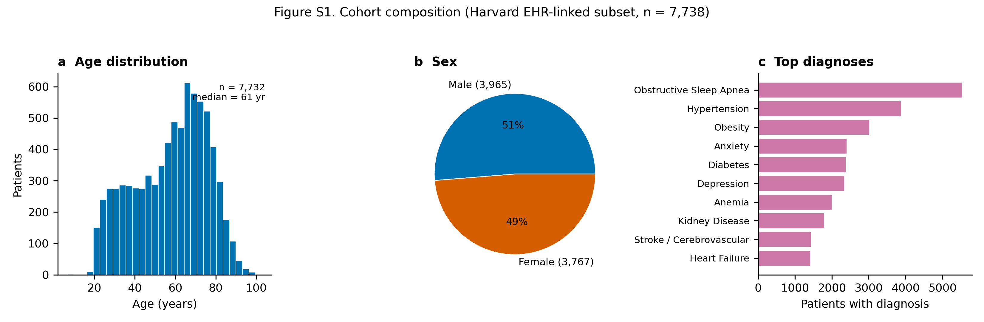
Figure S1. Cohort composition of the 7,738 EHR-linked patients. (a) Age distribution (median 61 years, range 7-103). (b) Sex (Male n=3,965, Female n=3,767). (c) The ten most prevalent broad clinical diagnosis categories, of which the largest were Obstructive Sleep Apnea (n=5,524); Hypertension (n=3,882); Obesity (n=3,016). This is a clinically referred polysomnography population, not a healthy community sample; diagnosis categories are not mutually exclusive.

S2. Variance and entropy vs. a non-heartbeat-locked noise floor
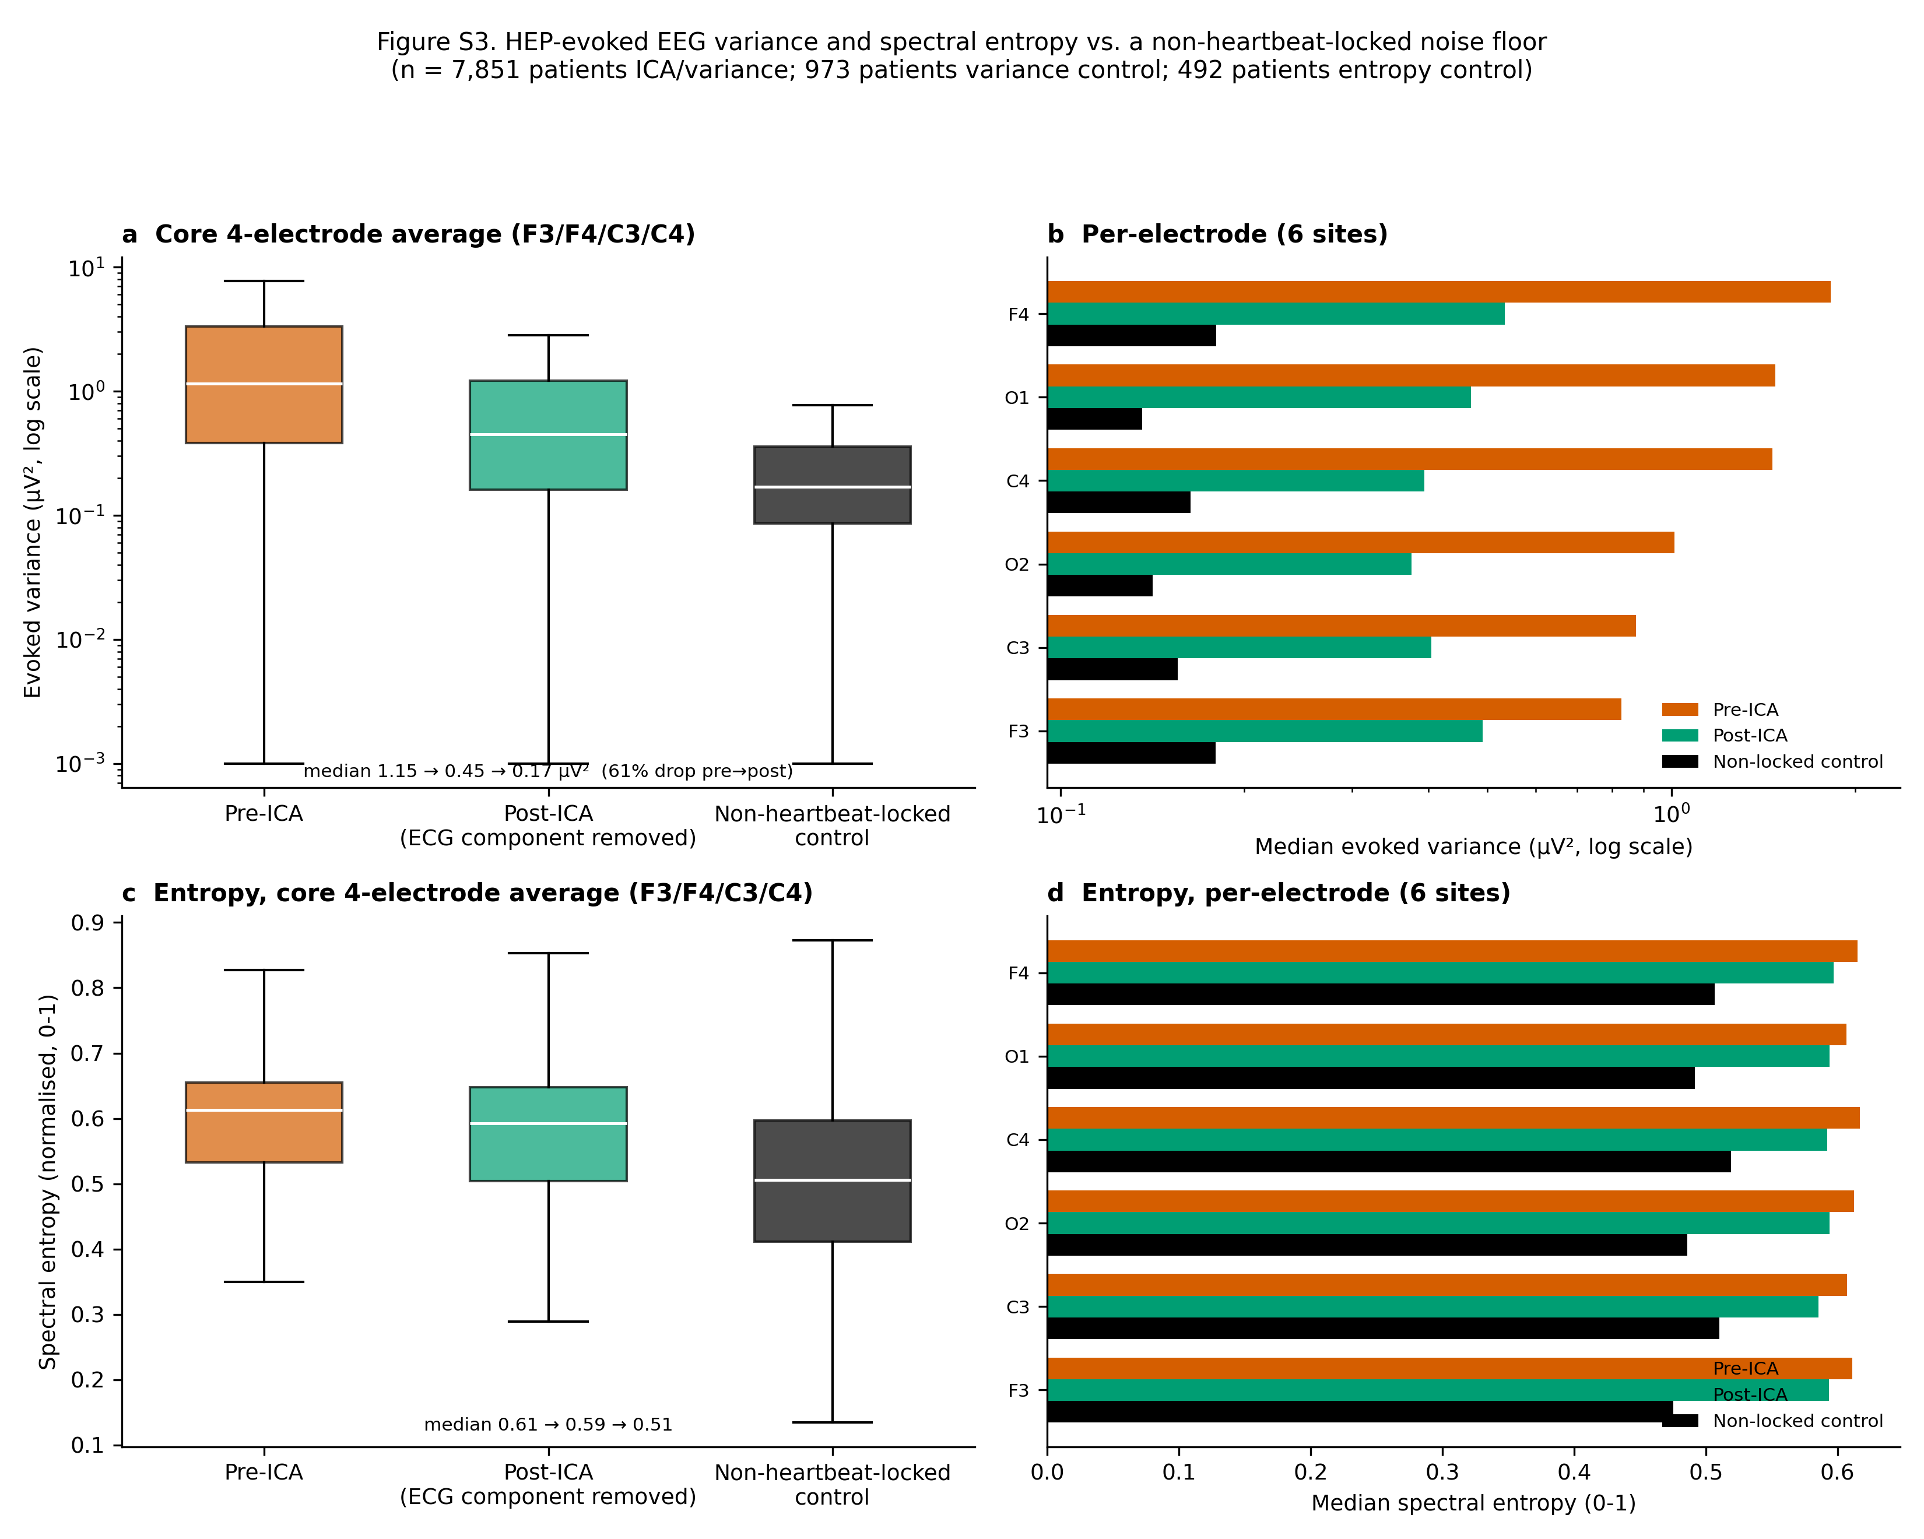
Figure S2. Absolute HEP-evoked EEG variance before vs. after excluding the ECG-flagged ICA component, alongside a non-heartbeat-locked control (n = 7,851 patients ICA; 973-patient control subsample; distributions are right-skewed, so medians on a log axis are reported rather than means). (a) Averaged over the core bilateral frontal-central quad (F3/F4/C3/C4): median 1.15 µV² pre-ICA to 0.45 µV² post-ICA (a 61% drop) vs. 0.17 µV² for the non-locked control — the same quality-controlled windows re-epoched around random pseudo-events instead of true R-peaks. (b) The same three-way comparison broken out per electrode, all six sites (§2.6). (c) Spectral entropy (normalised Shannon entropy of the evoked waveform's Welch power spectrum, 0-1) of the same three conditions, core electrode average (n = 492 patients, separate subsample). (d) Spectral entropy per electrode.
Removing the flagged component cut core-electrode HEP-evoked variance by 61% at the median, consistent with the fractional cleaning-effect reported in §3.2 (median 28%). The non-heartbeat-locked control gives the finite-sample noise floor this comparison is measured against (0.17 µV²), well below both pre-ICA (1.15 µV²) and post-ICA (0.45 µV²) — both still contain genuinely R-peak-locked structure, and post-ICA sitting clearly above the floor at every electrode (panel S2b) shows the flagged component's removal did not simply average the signal down to noise. Spectral entropy gives an independent, variance-free view of the same comparison: entropy fell from pre-ICA (0.61) to post-ICA (0.59) to the non-locked control (0.51), dropping only partially from pre- to post-ICA and remaining above the control at every electrode (panel S2d) — reinforcing §3.2's conclusion from a second, independent signal property.

S3. How much of the EEG is heart data: cross-correlation and mutual information
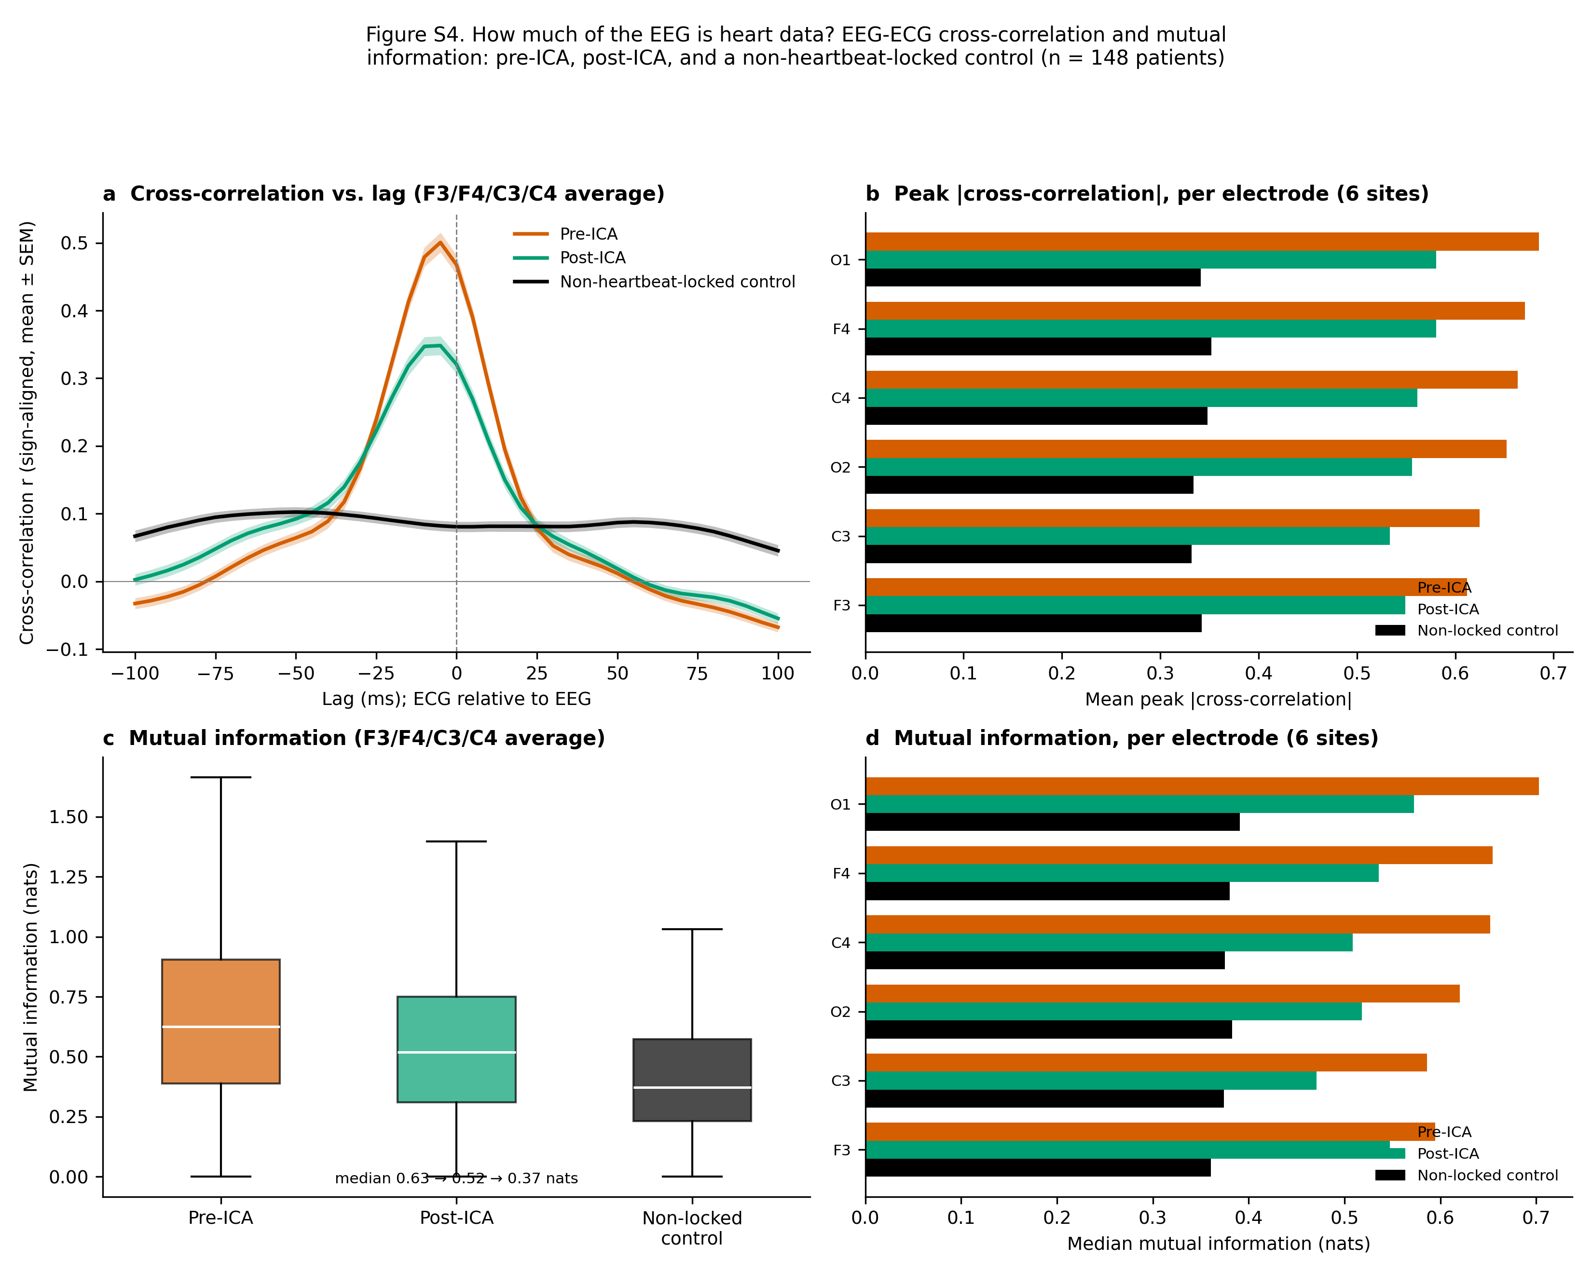
Figure S3. How much of the EEG is heart data: EEG-ECG cross-correlation and mutual information, pre-ICA, post-ICA, and a non-heartbeat-locked control (n = 148 patients, separate subsample re-fitting ICA to recover the paired evoked waveforms, which the main batch does not persist; §2.7). The control re-epochs the same pre-ICA EEG around random pseudo-events instead of true R-peaks and correlates it against the same real R-peak-locked ECG evoked average — the chance-level relationship expected if the EEG evoked waveform carried no genuine R-peak-locked structure at all. (a) Lag-resolved cross-correlation between the core-electrode (F3/F4/C3/C4) HEP evoked average and the concurrent ECG evoked average, sign-aligned per channel before averaging (reference polarity is arbitrary; magnitude is not) and shown mean ± SEM across patients. (b) Mean peak |cross-correlation| (maximum over lag) per electrode, all three conditions. (c) Mutual information between the same waveform pairs, core-electrode average. (d) Mutual information per electrode.
Cross-correlation peaks close to zero lag in both real conditions (median peak lag -5 ms pre-ICA, -10 ms post-ICA), consistent with the near-instantaneous volume-conduction assumption behind the zero-lag regression estimator (§2.3). Peak correlation strength drops from pre-ICA (mean |r| = 0.64) to post-ICA (mean |r| = 0.56) to the non-locked control (mean |r| = 0.34), and mutual information drops the same way, from 0.63 to 0.52 to 0.37 nats (panel c). Post-ICA sits clearly above the non-locked floor at every well-covered electrode (panels S3b, S3d): a non-trivial EEG-ECG relationship remains after cleaning, the same conclusion the realised cleaning-effect view (§3.2) and Supplementary Figure S2's noise-floor comparison independently reach. Because mutual information captures nonlinear as well as linear dependence, its post-ICA persistence rules out a nonlinear EEG-ECG relationship invisible to zero-lag Pearson correlation explaining away the R²-based result (§3.2).

S4. Power spectral density: pre-ICA, post-ICA, non-locked control, and ECG
A fourth view of the same question: the raw spectral shape of each evoked waveform, rather than a single correlation or variance summary. Welch power spectral density was computed on the same pre-ICA, post-ICA, and non-locked evoked waveforms as §S3, plus the patient’s own ECG evoked average, on the same 150-patient subsample.
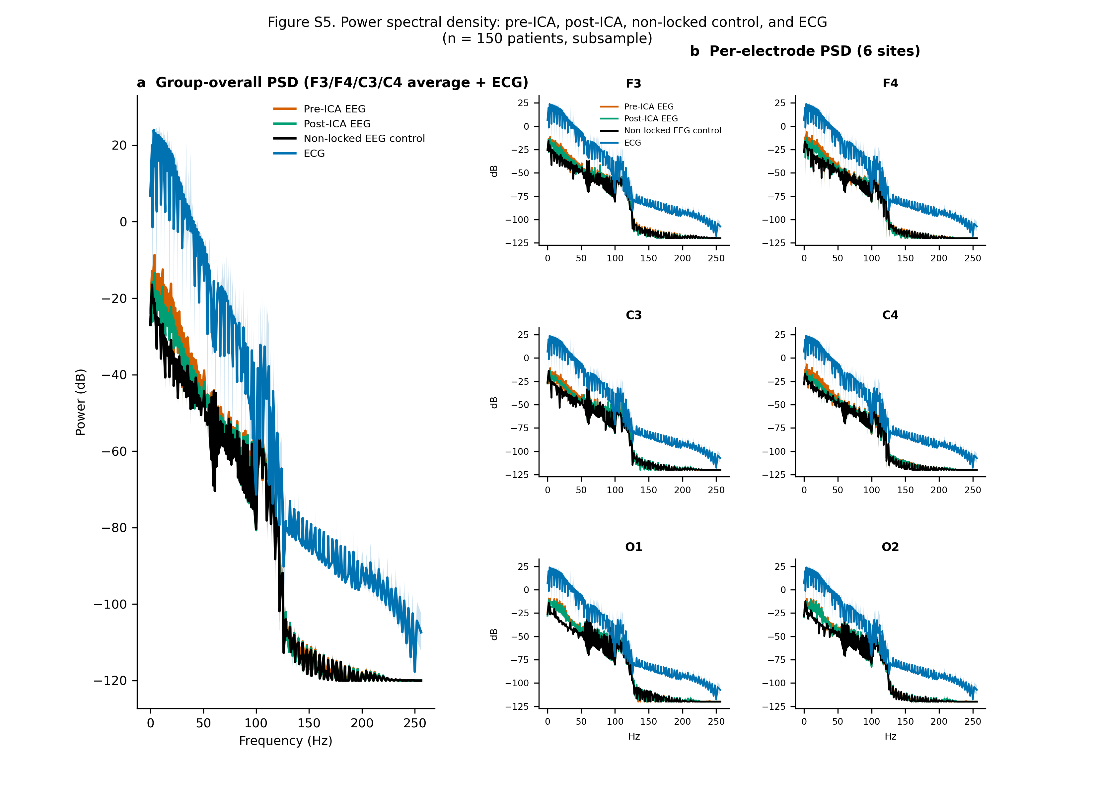
Figure S4. Power spectral density (Welch, dB) of the pre-ICA, post-ICA, non-heartbeat-locked control, and ECG evoked waveforms (n = 150 patients). (a) Group-overall: core 4-electrode (F3/F4/C3/C4) average, all four conditions overlaid (mean ± SEM). (b) Per-electrode: the same four-way overlay for each of the six well-covered sites (§2.6).
The ECG's own spectrum is broadband and structured (dominated by the QRS complex's sharp transient) compared to the flatter non-locked EEG control. Pre-ICA and post-ICA EEG spectra sit between these two references, both shaped more like the ECG than like the non-locked floor — a spectral-domain view of the same conclusion as §3.2 and §S3. Spectral shape is broadly similar across the six electrodes (panel b), consistent with Figure 2's finding that CFA varies in magnitude but not qualitatively in character across the scalp.

S5. Is the sex effect on CFA R² confounded by BMI?
Male patients had higher CFA R² than female patients (§3.4), and men in this cohort skew heavier, raising the question of whether the sex gap is really a BMI effect. On the BMI-available subsample (n = 6,127; derived from EHR height/weight vitals), an OLS regression of patient-mean CFA R² (outside QRS) on sex alone gave a male-vs-female coefficient of 0.031 (95% CI 0.020 to 0.041, p = 1.1e-08); adding BMI as a covariate left the sex coefficient essentially unchanged, 0.040 (95% CI 0.029 to 0.050, p = 3.2e-13), while BMI itself was an independent, significant predictor (coefficient 0.0029 per BMI unit, p = 1.5e-21).
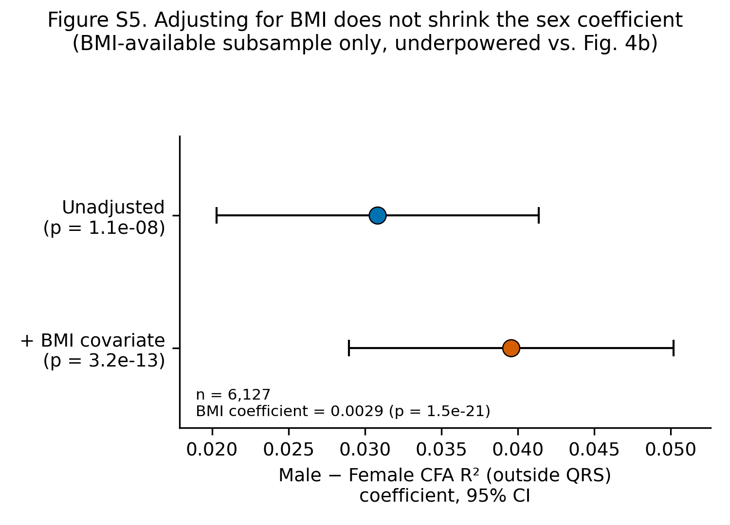
Figure S5. Male-vs-female CFA R² (outside QRS) OLS coefficient, unadjusted vs. BMI-adjusted, same BMI-available subsample (n = 6,127); points = coefficient, error bars = 95% CI.
The sex coefficient does not shrink after adjusting for BMI — if anything it is slightly larger — which argues against BMI being the driver of the sex effect seen in the full cohort. Although this subset is smaller than the full sex comparison (n = 6,127 vs. n = 7,729 in Figure 4b, which reached p = 1.5e-21), the expanded matched analysis now estimates both the unadjusted and BMI-adjusted sex coefficients precisely (p = 1.1e-08 and p = 3.2e-13, respectively). BMI and sex therefore contribute independently in this observational model; adjustment does not support BMI as the explanation for the sex gap.

S6. Time-domain sensitivity to recording duration
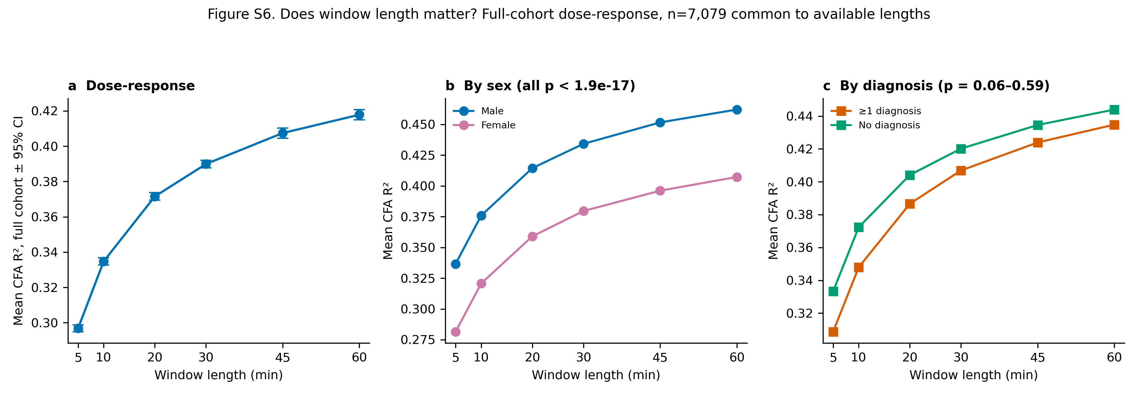
Figure S6. Time-domain sensitivity of CFA estimation to recording duration (n = 7,079 patients with usable data at every duration). (a) Mean CFA R² at 5, 10, 20, 30, 45, and 60 min (5 min: 0.30; 10 min: 0.33; 20 min: 0.37; 30 min: 0.39; 45 min: 0.41; 60 min: 0.42). (b) Sex-stratified and (c) diagnosis-stratified estimates. The sex difference was present at every available duration (Mann-Whitney, all p < 1.9e-17); diagnosis differences were not significant (p = 0.06–0.59).
Recording duration had a clear time-domain effect on the detectable cardiac contribution. Mean CFA R² increased from 0.30 at 5 min to 0.33 at 10 min, 0.37 at 20 min, 0.39 at 30 min, 0.41 at 45 min, and 0.42 at 60 min. Thus, 5-minute and 10-minute windows miss shared EEG-ECG structure that becomes detectable when more heartbeats are averaged. The incremental gain decreased from 0.04 R² units between 10 and 20 min to 0.02 between 20 and 30 min and 0.01 between 45 and 60 min, supporting a plateau after approximately 30 min. The sex difference persisted across all tested durations, whereas diagnosis differences were not significant in this matched subset.

Acknowledgements
The Human Sleep Project has received support from the Glenn Foundation and the American Federation of Aging Research (AFAR) through the 2018 Glenn / AFAR Award for Medical Research Breakthroughs in Gerontology (BIG) (2018), the American Academy of Sleep Medicine (AASM) through a 2019 Strategic Research Award, the National Institutes of Health (NIH) (R01NS102190, R01NS102574, R01NS107291, RF1AG064312, RF1NS120947, R01AG073410, R01HL161253, R01NS126282, R01AG073598), the National Science Foundation (NSF 2014431), and through the Henry and Allison McCance Center for Brain Health.

References
1. Dirlich G, Vogl L, Plaschke M, Strian F. Cardiac field effects on the EEG. Electroencephalogr Clin Neurophysiol. 1997;102(4):307-315.
2. Kern M, Aertsen A, Schulze-Bonhage A, Ball T. Heart cycle-related effects on event-related potentials, spectral power changes, and connectivity patterns in the human ECoG. NeuroImage. 2013;81:178-190.
3. Park H-D, Blanke O. Heartbeat-evoked cortical responses: underlying mechanisms, functional roles, and methodological considerations. NeuroImage. 2019;197:502-511.
4. Coll M-P, Hobson H, Bird G, Murphy J. Systematic review and meta-analysis of the relationship between the heartbeat-evoked potential and interoception. Neurosci Biobehav Rev. 2021;122:190-200.
5. Steinfath TP, et al. Heartbeat-evoked responses in M/EEG: a systematic review of methods with suggestions for analysis and reporting. Psychophysiology. 2026;63(4):e70297. doi:10.1111/psyp.70297.
6. Hyvarinen A, Oja E. Independent component analysis: algorithms and applications. Neural Netw. 2000;13(4-5):411-430.
7. Gramfort A, et al. MEG and EEG data analysis with MNE-Python. Front Neurosci. 2013;7:267.
8. Dirlich G, Dietl T, Vogl L, Strian F. Topography and morphology of heart action-related EEG potentials. Electroencephalogr Clin Neurophysiol. 1998;108(3):299-305.
9. Virjee R-I, Kandasamy R, Garfinkel SN, Carmichael DW, Yogarajah M. Review of methods to derive the heartbeat-evoked potential: past practices and future directions. Soc Cogn Affect Neurosci. 2026:nsag057. doi:10.1093/scan/nsag057.
10. Tochikubo O, Miyajima E, Shigemasa T, Ishii M. Relation between body fat-corrected ECG voltage and ambulatory blood pressure in patients with essential hypertension. Hypertension. 1999;33(5):1159-1163. doi:10.1161/01.HYP.33.5.1159.
11. Ablin P, Cardoso J-F, Gramfort A. Faster independent component analysis by preconditioning with Hessian approximations. IEEE Trans Signal Process. 2018;66(15):4040-4049.
12. Kraskov A, Stögbauer H, Grassberger P. Estimating mutual information. Phys Rev E. 2004;69(6):066138.
13. Benjamini Y, Hochberg Y. Controlling the false discovery rate: a practical and powerful approach to multiple testing. J R Stat Soc Series B. 1995;57(1):289-300.
14. The Human Sleep Project, v2.0. Brain Data Science Platform (BDSP). https://bdsp.io/content/hsp/2.0/

